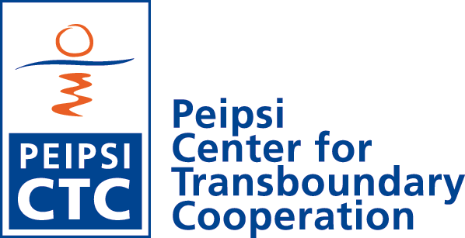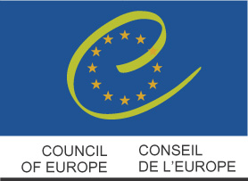

CALL FOR THE APPLICATIONS

SUMMER SCHOOL

CROSS BORDER COOPERATION IN THE NEW EU EXTERNAL BORDER REGIONS

Värska; Põlva county – Estonia
21-26 August 2005

Peipsi Center for Transboudnary Cooperation is organizing international summers school on cross border cooperation and multiculturalism in the border regions.
Summer school will take place in Värska, South of Estonia. (You can find more information on Värska municipality web site: www.verska.ee).
The summer school venue takes place in the close vicinity of Lake Peipsi/Chudskoe – the biggest transboundary Lake in Europe, situating in the Estonian-Russian border.

Funder: Summer school is supported by the Council of Europe, Confidence building measures Programme

Organizer:
Peipsi Center for Transboundray Cooperation
Aleksandri 9; Tartu 50304
Estonia
Contact persons: Iti Aavik, Gerli Hämmal
E-mail: gerli@ctc.ee
Tel/Faks: 372 7 302302
www.ctc.ee

Eligibility:

The summer school is targeted for the citizens of Estonia, Latvia, Lithuania, Russian Federation (Leningrad and Pskov oblasts), Ukraine and Belarus; representing the NGOs and local municipalities.
All participants are expected to have some practical experience in cross border cooperation projects and regional development work.

Language: the summer school language is English and good English language command is compulsory

Cost policy of the summer school
Summer school is free of charge (accommodation, meals, excursions, materials, lectures).
There is no travel reimbursement for the participants.
Participants are expected to cover their own travel costs to/from Estonia. However some travel grants up to 80 EUROs are available for participants from Russia and Belarus upon the request.

Introduction to the topic

Europe's borders have experienced historic changes since the beginning of the 1990s. New borders have been created to demarcate the boundaries of newly formed states. The end of the division of Europe offers new opportunities to establish neighbourly relations, and to promote tolerance and understanding between border populations.

It can be examined in many Eastern European countries that the border regions have remained peripheries of the country, with high rate of unemployment, depopulation, etc. and they often feel themselves isolated from the rest of the state. However, it has been proved in other regions that one of the possibilities to boost the local development of peripheral and underdeveloped areas could be through more active transfrontier cooperation and contacts and joint projects between different sectors across the borders.

It has also been stated several times in policy documents, that European integration should be greatly based on soft means and the most effective approach to provide security and stability between the EU and its new neighboring states would be co-operation scenarios and not enhancing security in military terms. It is very important to promote partnership, networks between specialists from different countries, and to learn from each-others experiences, to increase tolerance, understanding and good-neighborly relations between inhabitants.

Methods of the summer school
- Lectures
- Group work
- Individual work
- Study tours in the border region

Topics of the summer school:
- Cross border cooperation theories. General principles and connection between cross border cooperation and regional development
- Council of Europe policies for transfrontier cooperation. Legal basis for transfrontier cooperation
- EU programs and policies on cross border cooperation (European Neighborhood Policy; etc).
- Financial possibilities to support cross border cooperation (EU, Council of Europe, bilateral aid, other donors). Practical cross border cooperation project writing
- Cross border cooperation structures: Euroregions, Councils, etc
- Multiculturalism and local democracy in border regions
- Different fields of cross border cooperation: youth work, environment, tourism, and business cooperation.

Lecturers:
The lecturers of the summer school are university teachers; specialists from the Council of Europe and EU institutions; practitioners from Euroregions, NGOs and local municipalities involved with cross border cooperation.

Deadline of applications: 20 June 2005
The results of the selection will be made by 4 July to your e-mail address
Outline of the program

Day 1
Arrival of participants

Get together in Värska; Introduction of participants

Short walking tour in Värska village Introduction to computer class.

Day 2: General principles, role, actors of cross border cooperation in Europe

Lecture: General principles, role, actors of cross border cooperation.

Lecture: Council of Europe policies and legal basis for transfrontier cooperation

Lecture: Border policies in EU. Cross border cooperation between EU and NIS countries

In the afternoon: Meeting in local municipality

Introduction to group works

Day 3: Multiculturalism and local democracy in border regions

Lecture: Multiculutralism in border regions. Local democracy building

Lecture: Local community development and cross border cooperation

Lecture: Border regions and minorities

In afternoon field trips to Setu Minority national Museum

Day 4: Cross border structures and different fields of cooperation

Lecture: Cross border structures in Europe: Euro regions, joint councils

Lecture: East-West cross border cooperation. Multiculturalism. Cultural differences

In the afternoon field trip to the Estonian-Russian border station. Meeting with border guards

Day 5: Different fields of cross border cooperation:

Lecture: Youth cooperation and exchange programs. Models for youth cooperation

Lecture: SME development and business cooperation in border areas.

Lecture: Environmental cross border cooperation;

Day 6:

Finalizing of group works. Presentations by groups.

Concluding lecture

Evaluation of the summer school

Farewell party

APPLICATION FORM

ALL THE MATERIALS ARE TO BE SENT IN ENGLISH!!!

1) Personal and professional information

Name

Permanent Address

Organization and position

Telephone/Fax/

E-mail

Foreign language proficiency (use: excellent, good, sufficient):

English:

Russian________________________________________________________________________

2) CURRICULUM VITAE (max. 2 pages)

3) MOTIVATION Letter (please describe in 2-4 pages)

- Your professional background, description of your current job

- Describe cross border cooperation in your region and name 2-3 problems areas that could be solved with more efficient cooperation with neighbors across the border.

- Overview on the international and/or cross border cooperation projects you have been involved with. Positive/negative experiences

- Please describe more in detailed one cross border cooperation project idea you would like to implement in the future

- Why do you want to learn more about cross border cooperation?

- Name 3-5 topics issues to cross border cooperation, you are mostly interested in.

Please submit your application form; CV and motivation letter to:
Peipsi Center for Transboundary Cooperation:
Gerli Hämmal: gerli@ctc.ee OR
Fax: +372 7 302302

DEADLINE 30 June 2005

Council of Europe; http://www.coe.int/T/E/Legal_Affairs/Local_and_regional_Democracy/

